**Ideation Phase**

**Empathize & Discover**

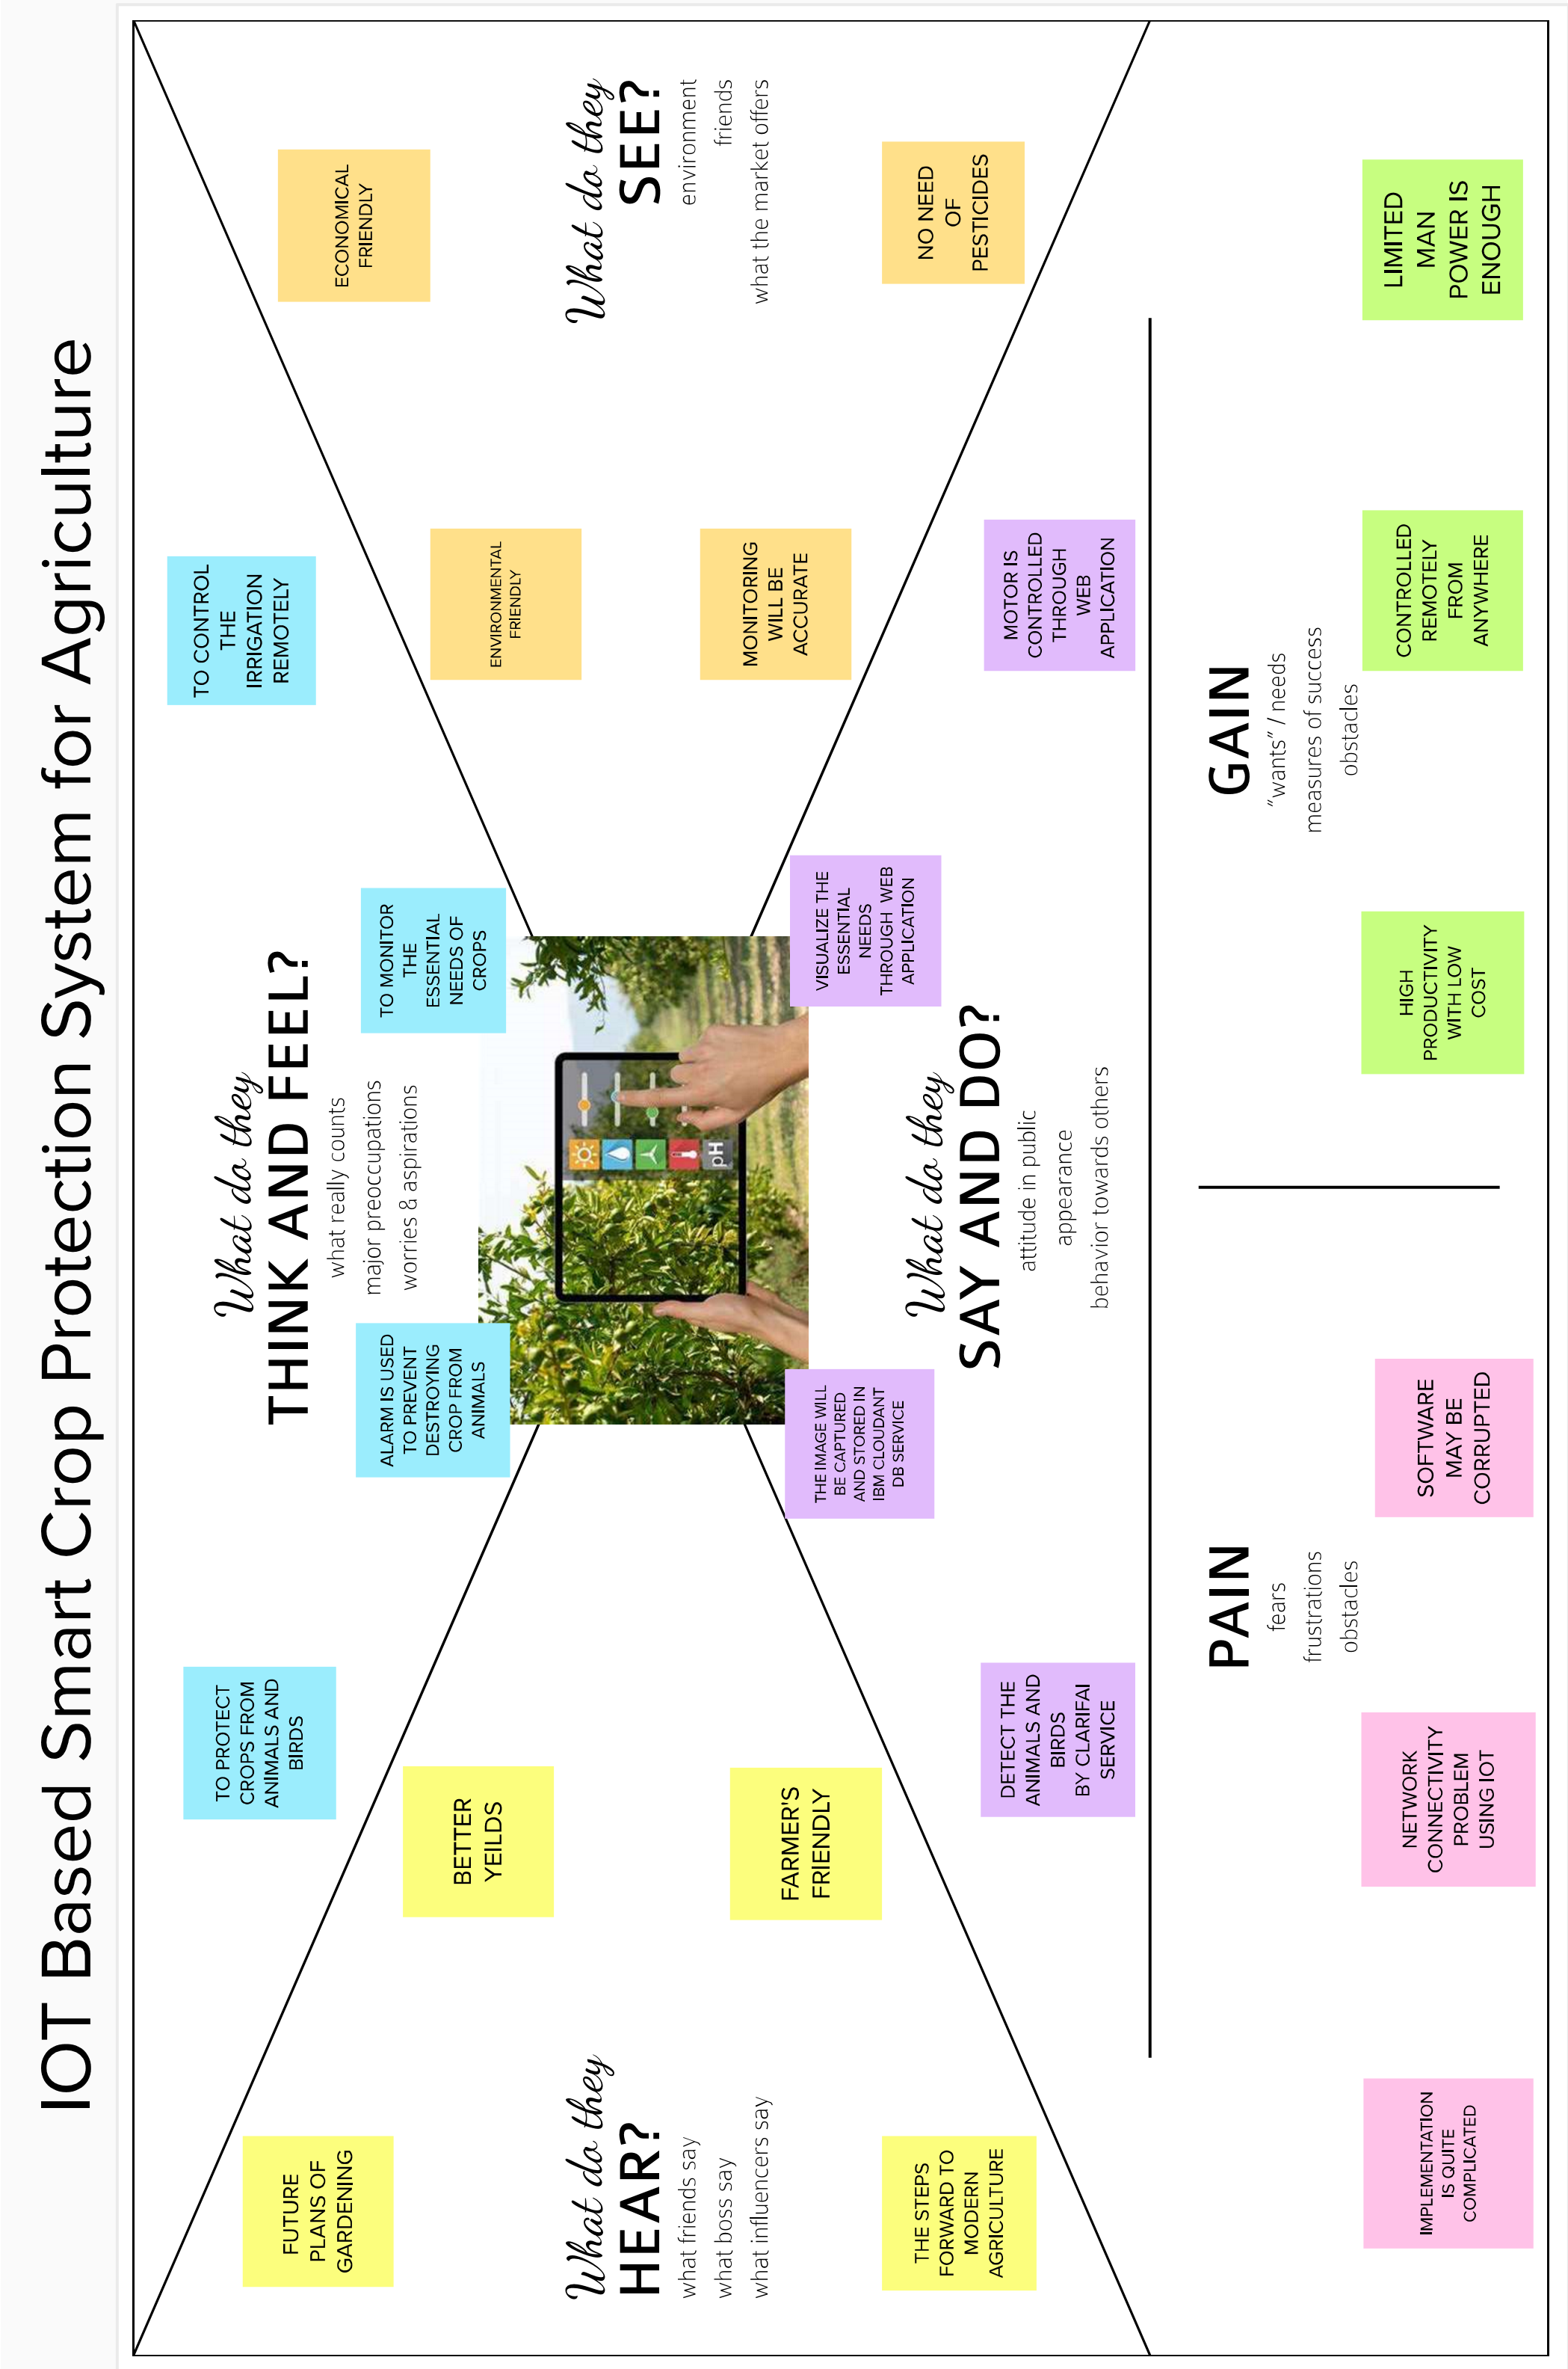**Date** : 10 September 2022

**Team ID**: PNT2022TMID20272

**Project Name Project** : IOT Based Smart Crop Protection System for Agriculture

**Maximum Marks** :4 Marks